University Of Engineering and Technology, Lahore
Computer Engineering Department

Course Name: Programming Fundamentals | Course Code: CMPE-112L
Assignment Type: Lab tasks | Dated: 25 May 2026
Semester: First | Session: 2026 Spring
Lab/Project/Assignment #: 1 | CLOs to be covered: CLO 2
Lab Title: MAP, Filter and Reduce | Teacher Name: Hafiz Muhammad Mubashar
Lab Evaluation:

CLO2 | Apply appropriate programming techniques to create executable programs to solve well defined problems
CLO2 | Level1 | Level2 | Level3 | Level4 | Level5 | Level6
(5)
Total |  |  |  |  |  | /5
Rubrics for Current Lab Evaluation
Scale | Marks | Level | Rubric
Excellent | 5 | L1 | Submitted all lab tasks, BONUS task, have good understanding.
Very Good | 4 | L2 | Submitted the lab tasks but have good understanding
Good | 3 | L3 | Submitted the lab tasks but have weak understanding.
Basic | 2 | L4 | Submitted the lab tasks but have no understanding.
Barely Acceptable | 1 | L5 | Submitted only one lab task.
Not Acceptable | 0 | L6 | Did not attempt
Week 13 LAB
MAP, Filter and Reduce
Lab Goals/Objectives:
• To understand and apply functional programming tools (map, filter, and reduce) in Python.
• To practice passing anonymous lambda functions as operational logic into higher-order functions.
• To master transforming collections, extracting selective elements, and rolling up datasets into a single aggregate value.
Equipment Required:

* Computer/Laptop
* Python 3.14
* VS Code or pycharm

Theory:
Python provides a powerful suite of higher-order functions designed to process iterables cleanly and efficiently without relying on explicit for or while loops.

Lab Work:

Task 1: Transforming Numbers (map() and Squaring)
nums = [1, 2, 3, 4, 5]
print(list(map(lambda x: x**2, nums)))
Result:

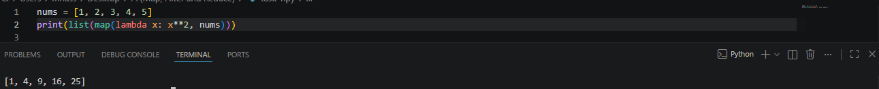

Task 2: Transforming Strings (map() and Capitalization)
words = ["python", "lambda", "map"]
print(list(map(lambda w: w.upper(), words)))

Result:

Task 3: Selective Extraction (filter() and Even Numbers)

nums = [1, 2, 3, 4, 5, 6]
print(list(filter(lambda x: x % 2 == 0, nums)))

Result:

Task 4: Content Filtering (filter() and String Length).

words = ["python", "map", "lambda", "filter"]
print(list(filter(lambda w: len(w) > 5, words)))

Result:

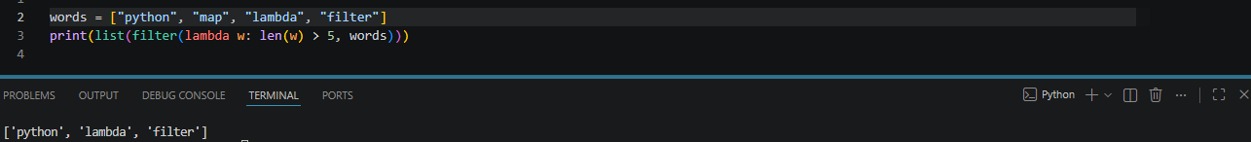

Task 5: Sequence Aggregation via Summation (reduce()).

nums = [1, 2, 3, 4, 5]
print(reduce(lambda x, y: x + y, nums))

Result:

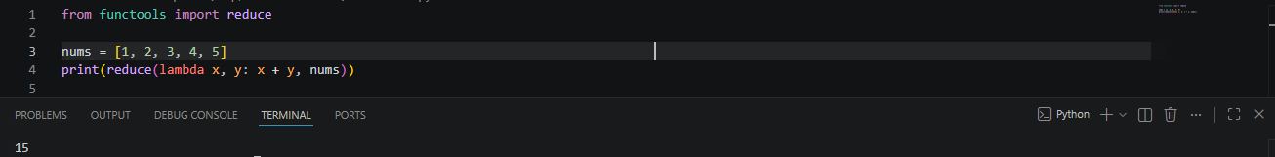

Task 6: Sequence Aggregation via Multiplication (reduce()).

nums = [1, 2, 3, 4, 5]
print(reduce(lambda x, y: x * y, nums))

Result:

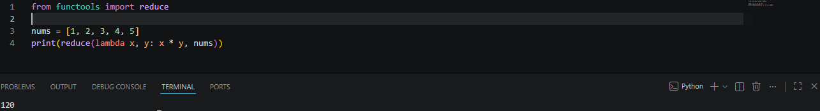

Conclusions:
This lab successfully demonstrates the core capabilities of functional array processing pipelines in Python. By mapping over items to alter state, filtering collections to extract specific criteria, and reducing sequences to aggregate summaries, we demonstrated how complex looping algorithms can be cleanly written using expressive, single-line lambda functions.

